EEE 320 INTRODUCTION TO INTERNET OF THINGS
INTERM APPLICATION HOMEWORKS
2025 Spring

Project Team: Öykü Aleyna GÖRÜR & Aslı İZCİ
Your Board: ESP32 Dev Board.
Your Wireless Communication Module: MFRC522 RFID Module.
Your LED Type: Common Cathode RGB LED
Your Software IDE: Arduino IDE.
Your Programming Language: Arduino, MicroPhython, CircuitPython or C/C++.
Application Purpose:
The application is a Smart Access Control System for an apartment or building entrance using an RFID-based security system, a touch sensor, and an RGB LED to indicate access status.
Functional Goals:
- Residents use authorized RFID cards to gain entry.
- Guests can be granted access via serial command (guest).
- Couriers/Postmen can press a touch sensor to request entry, triggering a temporary access notification (simulated here by turning on the LED).
- All access attempts are logged in the serial monitor with the RFID card ID (if scanned), and access results are visually represented with LED colors:
  - Green: Access granted (Resident)
  - Red: Access denied
  - Yellow: Guest or courier access
  - Blue: Standby/default
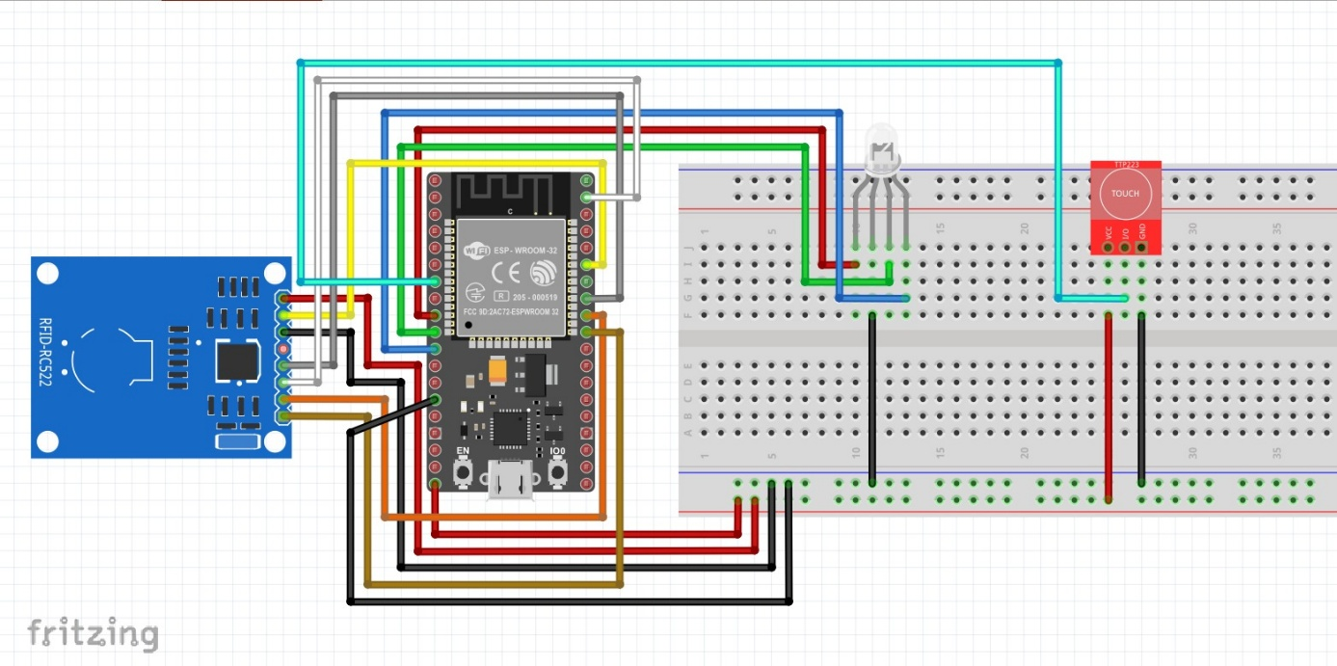
Fritzing Circuit Diagram:
Program codes
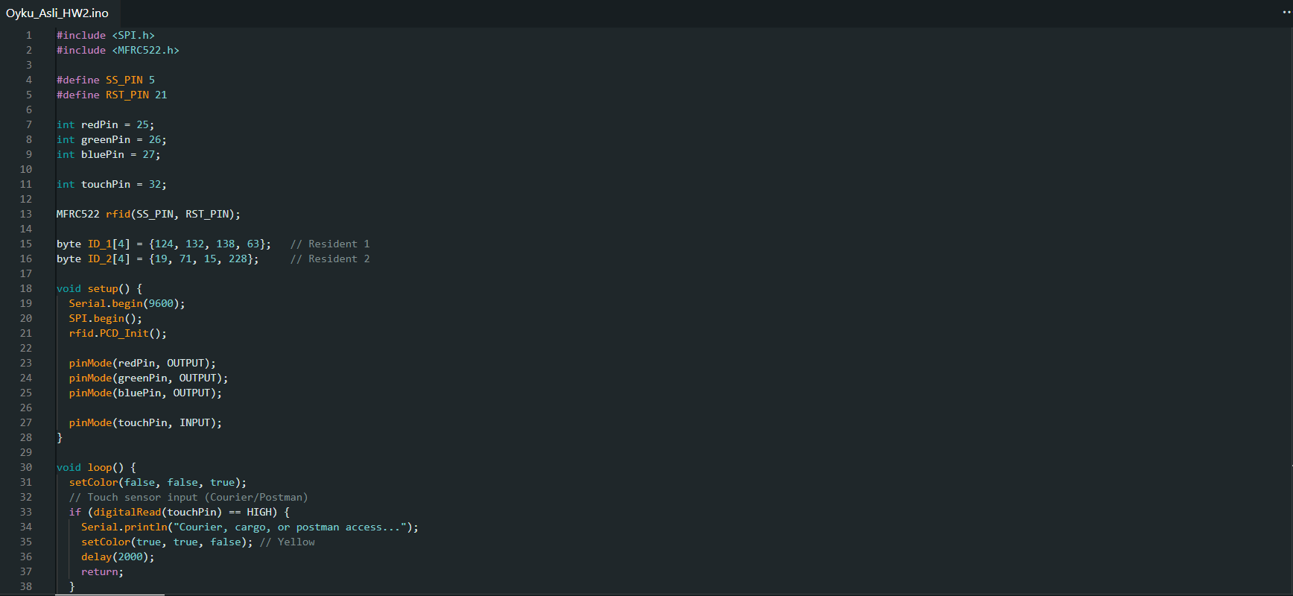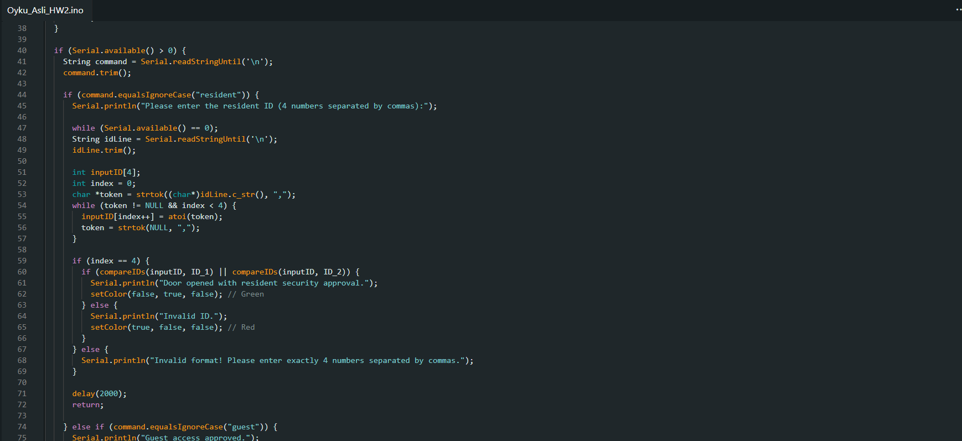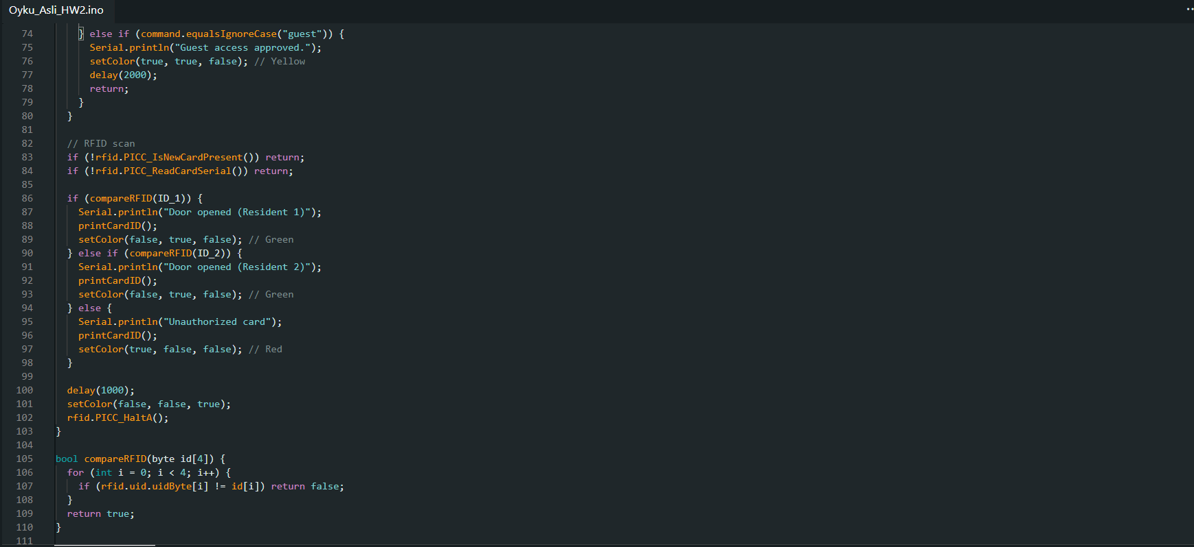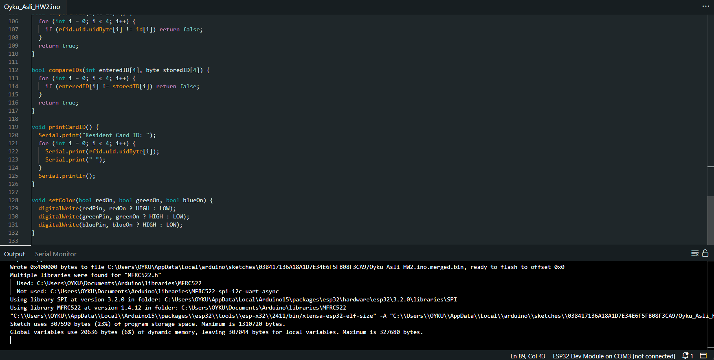
Simulation (Single screenshot):
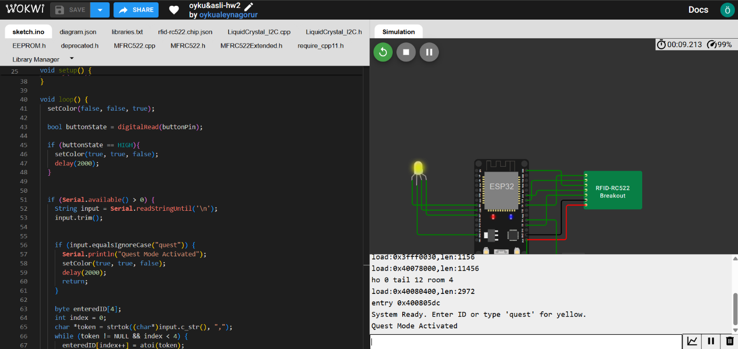
Photo for your circuit (only 1 photo):
